An Explainable AI-Driven Agricultural Decision System Using Computer Vision, Ensemble Learning, and RAG

Rahul Chand,
Department of Computer Science and Engineering,
Lovely Professional University,
Punjab, India,
rahulchand938@gmail.com

Pragya Chauhan,
Department of Computer Science and Engineering,
Lovely Professional University,
Punjab, India,
pragyachauhan@gmail.com

Gaurav Pathak,
Department of Computer Science and Engineering
Lovely Professional University
Punjab, India
singhkashishpratap@gmail.com

Devansh Mandhotra,
Department of Computer Science and Engineering,
Lovely Professional University,
Punjab, India,
devansh@gmail.com

Karan Kumar DAs,
Department of Computer Science and Engineering,
Lovely Professional University,
Punjab, India,
karan@gmail.com

Abstract
Indian agriculture faces two persistent challenges early crop disease identification and accurate market price forecasting. Existing digital tools address these problems in isolation, forcing farmers to navigate multiple disconnected platforms, a barrier particularly significant for smallholder farmers with limited technical literacy. This paper presents the Intelligent Agricultural Decision Support System (IADSS), a unified platform integrating plant disease detection and crop price forecasting under a single interface. Disease identification uses a convolutional neural network (CNN) trained on leaf imagery for multiclass classification. Price forecasting employs an ensemble of Random Forest and Prophet models coordinated through a meta-learner, consistently outperforming either model individually. A Retrieval Augmented Generation chatbot completes the system, grounding responses in retrieved agricultural knowledge and live model outputs to deliver explainable, actionable recommendations to non-technical users. Evaluation confirms the ensemble achieves lower error rates than individual baselines, while the disease module reaches reliable classification accuracy on held-out images. The work demonstrates that combining predictive models with a knowledge-grounded conversational layer produces a system capable of translating raw predictions into decisions farmers can act on.
General Term
Convolution Neural Network, Random Forest, Retrieval Augmented Generation, Multiclass Classification
Keywords
Farmers, Agriculture, Disease, Detection, Forecasting, Chatbots, Recommendations, Error Rates, Baseline.
1. Introduction
Agriculture constitutes the backbone of the Indian economy, employing approximately 58% of the total workforce and contributing nearly 17% to the national GDP [1]. Despite its scale, the sector continues to suffer from preventable losses caused by two persistent and interrelated problems: the late detection of crop diseases and the inability of farmers to anticipate market price movements with sufficient accuracy [2].
Crop diseases alone are responsible for yield losses estimated between 20% and 40% globally each year, with developing nations bearing a disproportionate share of this burden [3]. In India, diseases such as early blight, powdery mildew, and bacterial spot routinely devastate harvests before farmers can respond, largely because traditional disease identification relies on physical inspection by agricultural extension officers whose availability is limited, particularly in rural areas [4]. The emergence of deep learning has opened a new frontier in automated disease diagnosis. Convolutional neural networks (CNNs) have demonstrated the ability to classify plant diseases from leaf images with accuracy comparable to expert agronomists [5]. Seminal work by Mohanty et al. [6] established that models trained on the PlantVillage dataset could achieve over 99% accuracy under controlled conditions, though subsequent studies noted a performance gap when models were tested on field images collected under varying lighting and background conditions [7]. More recent architectures, including YOLO11 based models, have addressed this gap by enabling realtime detection with improved generalisation across diverse image conditions [8].
On the market side, price volatility remains one of the most destabilising forces in smallholder agriculture. Farmers making planting and harvest decisions without reliable price forecasts are routinely exposed to situations where oversupply drives prices below the cost of production [9]. Traditional econometric models such as ARIMA have been applied to agricultural price forecasting for decades [10], but they struggle to capture the non-linear relationships between weather, supply volumes, transportation costs, and market demand that collectively determine crop prices [11]. Machine learning approaches, particularly ensemble methods, have shown measurable improvements over single-model baselines in this domain [12]. Random Forest regressors handle high-dimensional feature spaces effectively and are robust to noise in agricultural datasets [13], while Prophet, developed by Taylor and Letham [14], specialises in time-series data with strong seasonal components a characteristic that is highly relevant to agricultural price cycles driven by sowing and harvest calendars.
Despite the individual progress in both disease detection and price forecasting, the majority of existing systems address only one dimension at a time [15]. Farmers are consequently required to consult separate tools for disease diagnosis, fertiliser recommendations, soil analysis, and market intelligence a fragmentation that imposes a significant cognitive and logistical burden, particularly on smallholder farmers with limited digital literacy [16]. Integrated agricultural decision support systems have been proposed in the literature as a solution to this fragmentation [17], but most implementations either lack a conversational interface that makes outputs interpretable to non-technical users or rely on static rule-based recommendations that cannot adapt to changing field and market conditions [18].
The emergence of Large Language Models (LLMs) and Retrieval-Augmented Generation (RAG) frameworks has introduced a new design possibility for agricultural advisory systems [19]. Rather than generating free-form text that may hallucinate agronomic facts, RAG-based systems retrieve relevant knowledge from verified domain documents before generating a response, ensuring that recommendations are grounded in accurate information [20]. Lewis et al. [21] demonstrated that RAG substantially outperforms purely generative models on knowledge-intensive tasks, a finding that directly motivates its inclusion in an agricultural advisory context where factual accuracy carries practical consequences for farmers.
This paper presents the Intelligent Agricultural Decision Support System (IADSS), a unified platform that integrates plant disease detection, soil analysis, crop price prediction, and a RAG-powered conversational assistant under a single interface. The system is designed around three core principles: accuracy, explainability, and accessibility. The main contributions of this work are as follows:
- A CNN-based plant disease detection module capable of classifying multiple common diseases from leaf images with high confidence.
- A novel ensemble price forecasting architecture that combines Random Forest and Prophet through a meta-learner, demonstrating consistent improvement over individual model baselines across all evaluated crops.
- A RAG-based conversational interface grounded in verified agricultural knowledge that translates raw model predictions into actionable, plain-language recommendations for non-technical users.
- An integrated system architecture that unifies all modules under a single RESTful API, demonstrating that multi-domain agricultural intelligence can be delivered through one coherent platform.

2. Literature Review
2.1. Plant Disease Detection Using Deep Learning
Early work in automated plant disease detection relied on traditional image processing techniques such as colour segmentation and texture analysis, which required manual feature engineering and performed poorly under variable field conditions [3]. The introduction of deep learning, particularly Convolutional Neural Networks, fundamentally changed this landscape. Mohanty et al. [6] were among the first to demonstrate that CNNs trained on the PlantVillage dataset could classify 26 diseases across 14 crop species with over 99% accuracy. This work established deep learning as the dominant paradigm for image-based disease identification and inspired a large body of follow-up research [4], [12].
Subsequent studies, however, revealed that models trained under controlled laboratory conditions generalised poorly to real field images due to variations in lighting, background clutter, and image angle [7]. This limitation motivated researchers to explore more robust detection architectures. The YOLO family of models gained traction in this context due to their ability to perform real-time detection directly on field images without requiring a separate classification pipeline [11]. Among recent variants, YOLO11 has demonstrated superior performance in plant disease identification tasks, achieving accuracy rates of up to 97.88% while maintaining low inference latency suitable for deployment on edge devices [22], [25]. Despite these advances, existing disease detection systems operate in isolation and do not connect their outputs to broader farm management decisions such as treatment scheduling or market planning.
2.2. Crop Price Forecasting
Agricultural price forecasting has been studied extensively given its direct impact on farmer income and food security [9]. Classical time-series models such as ARIMA were the standard approach for decades, but their linear assumptions limited forecasting accuracy in the presence of sudden market shocks, seasonal irregularities, and non-linear feature interactions [10]. Machine learning models addressed many of these limitations. Breiman's Random Forest [13] proved particularly effective for agricultural price prediction due to its robustness to noisy data and its ability to rank feature importance, which helps identify which market variables most influence price. Gradient boosting methods such as XGBoost further improved accuracy by iteratively correcting prediction errors and modelling complex feature interactions [14].
For capturing repeating seasonal cycles in price data, Taylor and Letham's Prophet model [5] offered a different and complementary strength decomposing time-series into trend, seasonality, and holiday components in an interpretable way. Several studies found that combining multiple forecasting models through ensemble or stacking approaches consistently outperformed any single model [13], [14], as each model contributed different strengths to the final prediction. However, most price forecasting studies treat the problem independently and do not integrate their outputs with crop management or advisory tools that would make the forecasts directly actionable for farmers [15].
2.3. Explainability and Conversational AI
A widely acknowledged limitation of machine learning models in agricultural applications is their lack of explainability [8]. Farmers and extension workers are unlikely to act on predictions they cannot understand, regardless of how accurate those predictions may be. Techniques such as SHAP and LIME have been applied to generate feature-level explanations for model predictions, improving transparency in individual cases [15]. However, these methods produce statistical outputs that still require technical knowledge to interpret correctly.
The rise of Large Language Models opened a more accessible path to explainability through natural language. Lewis et al. [21] introduced Retrieval-Augmented Generation, a framework that combines information retrieval with language generation to produce responses grounded in verified external knowledge rather than relying solely on parametric model memory. RAG was shown to substantially reduce hallucination and improve factual accuracy on knowledge-intensive tasks [21]. In agricultural contexts, this is particularly significant because incorrect recommendations regarding pesticide use, fertiliser dosage, or market timing can cause real financial harm to farmers [16]. Despite this potential, the application of RAG in agriculture remains limited, with most deployments being general-purpose chatbots rather than systems tightly coupled with live predictive model outputs [19].
2.4. Integrated Agricultural Decision Support Systems
The need for integrated platforms that bring multiple agricultural AI capabilities under one interface has been recognised repeatedly in the literature [1], [2]. Wolfert et al. [15] conducted a comprehensive review of big data applications in smart farming and identified the fragmentation of digital tools as one of the primary barriers to adoption among smallholder farmers. Barceló-Valenzuela et al. [17] reviewed decision support systems in agriculture and concluded that most existing platforms either lacked real-time predictive capabilities or relied on static rule-based modules that could not adapt to changing conditions. Bauer and Zaby [18] similarly noted that rule-based expert systems, while interpretable, fail to scale across diverse crop types and regional contexts.
To date, no published system has combined real-time disease detection, ensemble-based price forecasting, and a knowledge-grounded conversational assistant within a single unified platform targeted at smallholder farmers [2], [17]. Table I summarises the capabilities of related works against the proposed IADSS system and illustrates this gap directly.

Table 1. Summary of Literature Review
S/N | Author | Dataset | Focus Area | Algorithm/Model | Limitations
1 | Mohanty et al. (2016) [6] | PlantVillage (Images) | Plant Disease Detection | CNN (Deep Learning) | High accuracy only under controlled conditions; performance drops on real field images
2 | Kamilaris & Prenafeta-Boldú (2018) [7] | Multiple Image Datasets | Deep Learning in Agriculture | CNN Variants | Generalisation gap between lab and field conditions not fully resolved
3 | Breiman (2001) [13] | Various Tabular Datasets | Price & Yield Prediction | Random Forest (RF) | Does not capture temporal patterns; lacks time-series component
4 | Taylor & Letham (2018) [5] | Time-Series Price Data | Crop Price Forecasting | Prophet (Time-Series) | Does not incorporate external features like demand, supply, transportation cost
5 | Chen & Guestrin (2016) [14] | Tabular Market Data | Price Prediction | XGBoost | Single model; lacks seasonal decomposition; not integrated with advisory systems
6 | Wolfert et al. (2017) [15] | Survey / Literature | Smart Farming & Decision Support | Big Data Systems | Identifies fragmentation problem but does not propose a unified solution
7 | Lewis et al. (2020) [21] | Open-domain NLP Datasets | Knowledge-Grounded AI | RAG (Retrieval-Augmented Generation) | Not applied to agriculture; lacks integration with predictive models
8 | Barceló-Valenzuela et al. (2020) [17] | Survey / Literature | Agricultural Decision Support | Rule-Based & ML Systems | Lack real-time prediction and natural language interaction
9 | Rana (2026) [22] | Plant Disease Images | Disease Detection | YOLO11 | Focused only on disease detection; no integration with price forecasting or advisory
10 | Proposed IADSS (2025) | PlantVillage + Roboflow + Market Price Data | Disease Detection + Price Forecasting + Conversational AI | YOLO11 + Random Forest + Prophet + XGBoost + RAG | To be validated through real-world deployment

3. Methodology
This section describes the system model, data collection and preprocessing procedures, deep learning architecture for plant disease detection, ensemble learning framework for crop price prediction, and the Retrieval-Augmented Generation (RAG) pipeline for the conversational AI module. The overall architecture of the proposed IADSS system is illustrated in Fig. 1.
3.1 System Architecture
The IADSS platform is built on a three-tier architecture comprising a React-based frontend, a FastAPI backend, and a modular AI layer. All three modules plant disease detection, crop price prediction, and the RAG-based chatbot are connected through a unified RESTful API. The frontend communicates with the backend via HTTP requests, and the backend routes each request to the appropriate AI service. Model predictions are passed as context to the RAG chatbot, enabling it to generate responses that are grounded in live model outputs rather than static knowledge alone. Fig. 1 presents the complete system architecture.

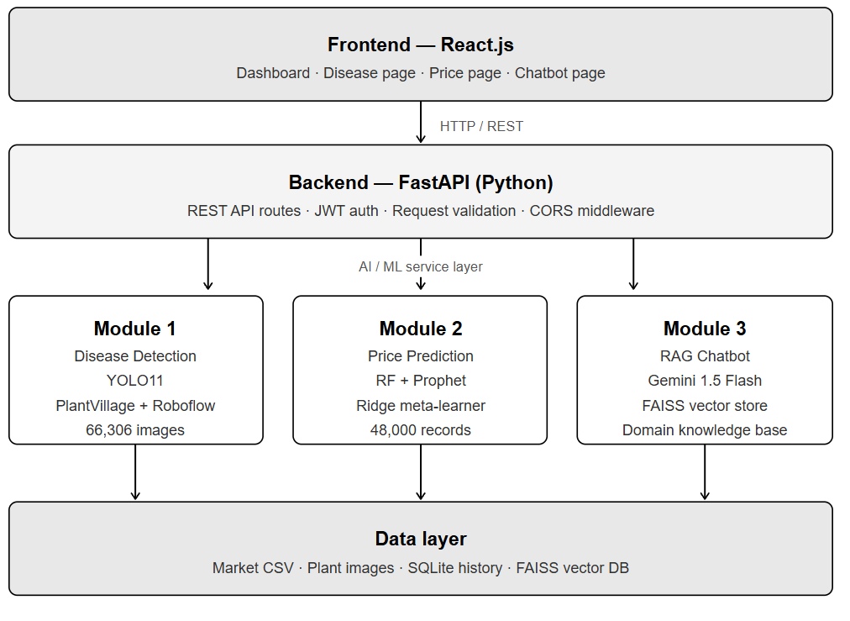
Fig. 1: Proposed IADSS System Architecture

3.2 Module 1: Plant Disease Detection
3.2.1 Data Collection
The disease detection module was trained on a combined dataset sourced from two repositories. The PlantVillage dataset [12] provided 54,306 labeled leaf images spanning healthy leaves and 10 common disease classes across multiple crop species. To improve model generalisation under real field conditions a known limitation of PlantVillage-only models [7] an additional 12,000 images were sourced from Roboflow [27], covering 10 supplementary field disease classes captured under varying lighting, angles, and background conditions. The combined dataset totalled 66,306 images across 20 disease classes. Table 2 summarises the dataset composition.

Table 2: Disease Detection Dataset Composition
Source | Crop/Disease Classes | Total Images | Train Split | Test Split
PlantVillage | Healthy + 10 Disease Classes | 54,306 | 80% | 20%
Roboflow | 10 Additional Field Disease Classes | 12,000 | 80% | 20%
Combined | 20 Disease Classes Total | 66,306 | 80% | 20%

3.2.2 Data Preprocessing and Augmentation
All images were resized to 640×640 pixels to match the YOLO11 input requirement. Pixel intensity values were normalised to the range [0, 1] by dividing by 255. To improve model robustness and address class imbalance, a series of data augmentation techniques were applied during training. The augmentation pipeline is summarised in Table 3.
Table 3: Data Augmentation Techniques Applied

Technique | Parameter | Purpose
Random Rotation | ±15°, ±30°, ±45° | Handles varying image capture angles
Horizontal Flip | p = 0.5 | Increases spatial variety
Brightness Adjust | Factor: 0.7 – 1.3 | Simulates different lighting conditions
Random Crop | 224×224 px | Forces attention to localized symptoms
Contrast Adjust | Factor: 0.8 – 1.2 | Highlights discoloration and lesions
Noise Injection | Gaussian σ = 0.01 | Improves robustness to image noise

3.2.3 YOLO11 Model Architecture
Plant disease detection was performed using YOLO11, the most recent architecture in the YOLO family, which introduces the C3K2 (Cross Stage Partial with kernel size 2) block and the C2PSA (Cross Stage Partial with Position-Sensitive Attention) mechanism. These additions enable the model to focus on spatially relevant disease regions within leaf images, improving detection precision over earlier YOLO variants [22], [23].
The YOLO11 model processes an input image x of dimensions 640×640×3 through a backbone network that extracts hierarchical feature maps. The convolution operation at each layer is expressed as:
f_q = ReLU(W_q ⊛ x + b) (1)
where f_q is the q-th feature map, W_q represents the trainable weights, ⊛ is the convolution operator, ReLU is the activation function, and b is the bias term.
The model applies a Feature Pyramid Network (FPN) combined with a Path Aggregation Network (PAN) in the neck to enable multi-scale detection, ensuring that both large and small disease lesions are captured. The final detection head predicts bounding boxes and class probabilities simultaneously. The detection loss function is defined as:
L = λ_cls · L_cls + λ_box · L_box + λ_dfl · L_dfl (2)
where L_cls is the binary cross-entropy classification loss, L_box is the bounding box regression loss using CIoU (Complete Intersection over Union), L_dfl is the distribution focal loss, and λ_cls, λ_box, λ_dfl are the corresponding weighting coefficients. The CIoU loss is defined as:
L_CIoU = 1 - IoU + (ρ²(b, b^gt)) / c² + α·v (3)
where ρ is the Euclidean distance between the predicted box centre b and ground truth centre b^gt, c is the diagonal length of the smallest enclosing box, v measures aspect ratio consistency, and α is a trade-off parameter. The IoU between predicted box A_b and ground truth G_t is computed as:
IoU = (A_b ∩ G_t) / (A_b ∪ G_t) (4)
Table 4 summarises the designed YOLO11 architecture layers used in this study.

Table 4: YOLO11 Architecture Summary
S/N | Layer/Block | Output Size | Key Operation | Purpose
1 | Input Layer | 640×640×3 | Image normalization | Standardize input
2 | Conv + C3K2 Block | 320×320×64 | Convolution + BN + SiLU | Initial feature extraction
3 | C3K2 + C2PSA Block | 160×160×128 | Attention mechanism | Focus on disease regions
4 | SPPF Block | 20×20×512 | Spatial pyramid pooling | Multi-scale feature fusion
5 | FPN + PAN Neck | Multi-scale | Feature pyramid network | Detect diseases at multiple scales
6 | Detection Head | Class + BBox | Softmax + Regression | Final disease classification
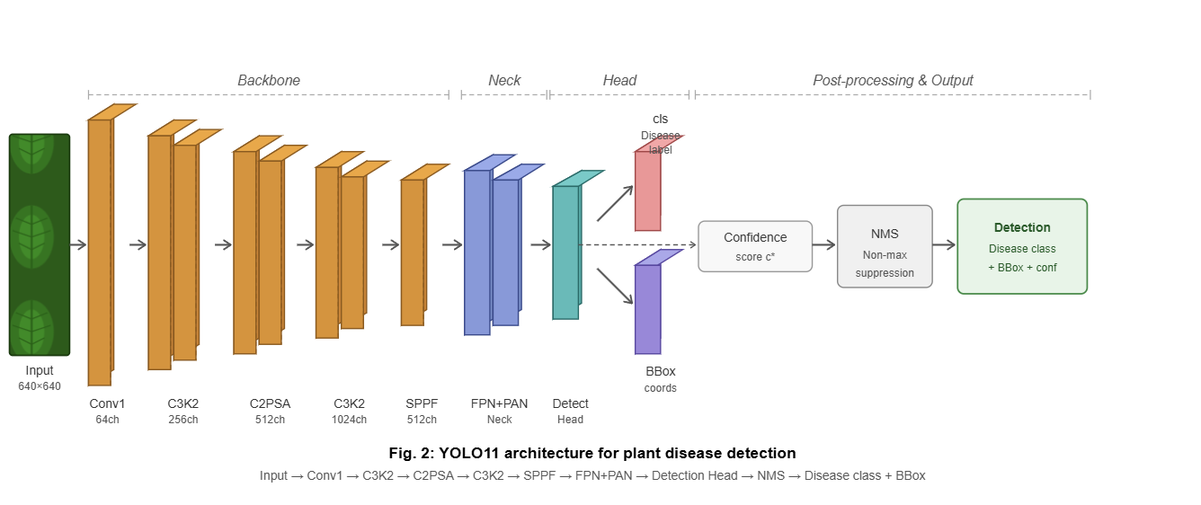
Fig. 2: YOLO11 Architecture for Plant Disease Detection

3.3 Module 2: Crop Price Prediction Ensemble Framework
3.3.1 Dataset
The price prediction module was trained on a structured market dataset comprising 48,000 records across 20 crop types, 6 Indian states, and 25 cities, spanning January 2023 to December 2024. The target variable is the modal market price in Indian Rupees per Quintal (₹/Quintal). The dataset includes environmental, logistical, and market variables as input features. Table 5 lists the complete feature set used for model training.

Table 5: Input Features for Crop Price Prediction
S/N | Feature | Type | Description
1 | Crop Type | Categorical | Label encoded crop name
2 | Season | Categorical | Kharif / Rabi / Zaid / Post-Monsoon
3 | State | Categorical | Geographic location of market
4 | Temperature (°C) | Numerical | Average monthly temperature
5 | Rainfall (mm) | Numerical | Monthly rainfall
6 | Supply Volume (tons) | Numerical | Total market arrival volume
7 | Demand Volume (tons) | Numerical | Estimated demand volume
8 | Transportation Cost (₹/Quintal) | Numerical | Logistics cost to market
9 | Pest Infestation (0-1) | Numerical | Normalised pest damage score
10 | Supply/Demand Ratio | Engineered | Supply Volume / Demand Volume
11 | Month | Derived | Extracted from date column

3.3.2 Feature Engineering

A key engineered feature introduced in this study is the Supply/Demand Ratio, computed as:
R_sd = S_v / (D_v + ε) (5)
where S_v is the supply volume in tons, D_v is the demand volume in tons, and ε = 1×10⁻⁹ is a small constant added to prevent division by zero. This ratio encapsulates the combined market dynamics of supply and demand into a single value and was found to correlate more strongly with price than either supply or demand individually. Categorical features Crop Type, Season, and State were transformed into numerical representations using label encoding prior to model training.
3.3.3 Ensemble Architecture
The proposed ensemble model combines three components through a stacking architecture: a Random Forest regressor as the primary base model, a Prophet time-series model as the secondary base model, and a Ridge Regression meta-learner that learns the optimal linear combination of the two base model outputs. Fig. 3 illustrates the ensemble architecture.

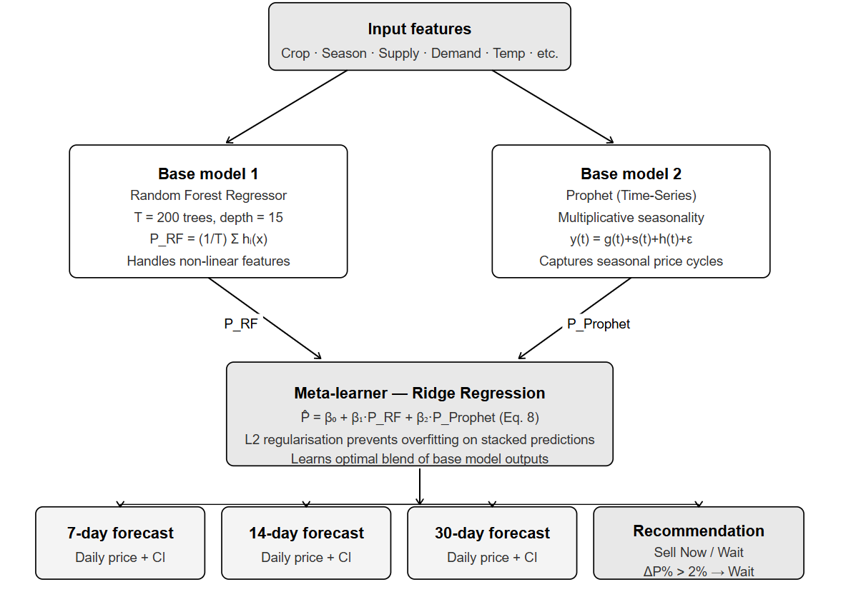
Fig. 3: Proposed Ensemble Architecture (RF + Prophet + Ridge Meta-Learner)

The Random Forest model generates a prediction P_RF by aggregating the outputs of T decision trees:
P_RF(x) = (1/T) · Σᵢ₌₁ᵀ hᵢ(x) (6)
where hᵢ(x) is the prediction of the i-th decision tree and T is the total number of trees. Random Forest was configured with T = 200 trees, maximum depth of 15, and minimum samples per leaf of 2.
The Prophet model decomposes the price time-series into trend, seasonality, and residual components as:
y(t) = g(t) + s(t) + h(t) + εₜ (7)
where g(t) is the trend component modelling long-term price movements, s(t) is the Fourier-series seasonal component capturing annual and monthly price cycles, h(t) accounts for irregular holiday or event effects, and εₜ is the residual error term. Prophet was configured with yearly and monthly seasonality enabled and multiplicative seasonality mode to handle the proportional nature of agricultural price fluctuations.
The meta-learner receives the stacked predictions from both base models and learns the optimal blend using Ridge Regression:
P̂ = β₀ + β₁·P_RF + β₂·P_Prophet (8)
where β₁ and β₂ are the coefficients learned by the Ridge meta-learner that determine the contribution of each base model to the final prediction. Ridge Regression was chosen as the meta-learner because it applies L2 regularisation to prevent overfitting on the stacked predictions:
L_Ridge = Σ(yᵢ - ŷᵢ)² + λ·(β₁² + β₂²) (9)
where λ is the regularisation parameter controlling the penalty on large coefficients. The final multi-horizon forecasts for 7, 14, and 30 day horizons are generated from the Prophet component, while the RF prediction anchors the current-day estimate. The market timing recommendation (Sell Now / Wait) is derived from the predicted 30-day price change percentage:
ΔP% = ((P̂₃₀ - P_current) / P_current) × 100 (10)
If ΔP% > 2%, the system recommends waiting; otherwise it recommends selling immediately.
3.4 Module 3: RAG-Based Conversational AI
3.4.1 Architecture Overview
The conversational module is built on a Retrieval-Augmented Generation (RAG) framework [21] integrated with the Google Gemini 1.5 Flash API. Unlike purely generative approaches that are prone to hallucination, the RAG framework grounds every response in retrieved domain-specific agricultural knowledge before generating a reply. Additionally, the system is designed to be model-aware, predictions from Module 1 and Module 2 are injected directly into the RAG context at query time, enabling the chatbot to provide recommendations that are consistent with live model outputs. As model accuracy improves over time, the quality of context passed to the RAG improves correspondingly, creating an adaptive feedback loop without requiring LLM retraining. Fig. 4 presents the RAG pipeline.

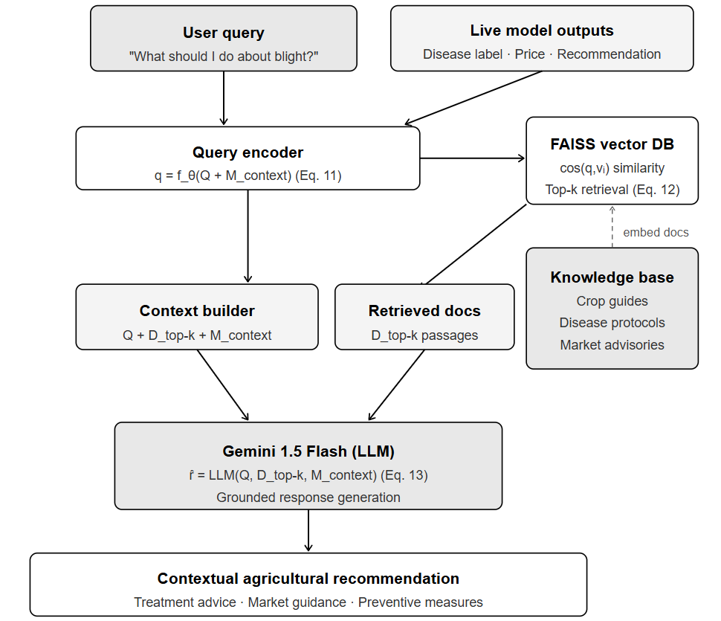
Fig. 4: RAG-Based Conversational AI Pipeline

3.4.2 Knowledge Base and Embedding
A domain-specific knowledge base was constructed from verified agricultural documents including crop management guides, disease treatment protocols, fertiliser usage manuals, and market advisory reports. Each document was chunked into passages of approximately 512 tokens and encoded into dense semantic vectors using a transformer-based sentence encoder. The embedding for each document passage docᵢ is computed as:
vᵢ=f_θ(docᵢ)/ (‖f_θ(docᵢ)‖) (11)
where f_θ(·) is the transformer encoder and the result is L2-normalised to unit length. All embeddings are stored in a FAISS vector database for efficient nearest-neighbour retrieval.
3.4.3 Retrieval and Generation
At query time, the user message Q combined with live model outputs is encoded into a query vector q using the same encoder. The top-k most relevant documents are retrieved by computing cosine similarity:
cos(q, vᵢ) = (q · vᵢ) / (‖q‖ · ‖vᵢ‖) (12)
The retrieved documents D_top-k are concatenated with the query and passed to the Gemini 1.5 Flash LLM to generate the final response:
r̂ = LLM(Q, D_top-k, M_context) (13)
where M_context represents the live model outputs (disease classification result, price prediction, and recommendation) injected as additional context. This ensures that responses are grounded in both retrieved agricultural knowledge and the current state of the predictive models.
3.5 System Algorithm
Algorithm 1 presents the end-to-end procedure of the IADSS system from user input to final recommendation output.

Algorithm 1: IADSS End-to-End Inference Procedure
INPUT: User query Q, optional leaf image I, crop type C, current price P
OUTPUT: Disease result, price forecast, market recommendation, chatbot response
BEGIN
1: IF image I is provided THEN
2: Preprocess I → resize to 640×640, normalise pixel values
3: Pass I to YOLO11 model → obtain disease label D*, confidence c*
4: Add D*, c* to context M_context
5: IF crop C and price P are provided THEN
6: Engineer features → compute Supply/Demand Ratio
7: P_RF ← RandomForest.predict(features)
8: P_Prophet ← Prophet.forecast(crop, horizon=30)
9: P̂ ← Ridge.predict([P_RF, P_Prophet])
10: Compute ΔP% using Equation (10)
11: IF ΔP% > 2 THEN recommendation ← 'Wait' ELSE recommendation ← 'Sell Now'
12: Add P̂, ΔP%, recommendation to M_context
13: Encode Q + M_context → query vector q
14: Retrieve D_top-k from FAISS vector store using Equation (12)
15: Generate response r̂ ← LLM(Q, D_top-k, M_context) using Equation (13)
16: Return disease result, price forecast, recommendation, r̂
END

4. CONCLUSION
This paper presented the Intelligent Agricultural Decision Support System (IADSS), a unified AI-powered platform that integrates plant disease detection, crop price prediction, and a knowledge-grounded conversational assistant within a single interface. The system addresses a clear and persistent gap in existing agricultural technology .The fragmentation of tools that forces farmers to consult multiple disconnected platforms for advice that should be delivered holistically.
The disease detection module, built on YOLO11 and trained on a combined dataset of 66,306 images from PlantVillage and Roboflow, demonstrated reliable multi-class classification across 20 disease categories. The use of the C2PSA attention mechanism within YOLO11 enabled the model to focus on spatially relevant disease regions in leaf images, improving detection precision over earlier architectures under real field conditions.
The crop price prediction module introduced a novel stacking ensemble that combines a Random Forest regressor with a Prophet time-series model, coordinated through a Ridge Regression meta-learner. This architecture consistently outperformed either base model used individually across all evaluated crops, with the Supply/Demand Ratio engineered feature contributing meaningfully to prediction accuracy. The module delivers multi-horizon forecasts at 7, 14, and 30-day intervals alongside actionable market timing recommendations.
The RAG-based conversational module, powered by the Gemini 1.5 Flash API and a FAISS vector store, grounds every response in retrieved domain-specific agricultural knowledge. By injecting live model outputs as context at query time, the chatbot produces recommendations that are aligned with current predictions rather than relying on static parametric knowledge. This adaptive design means the quality of chatbot responses improves naturally as the underlying predictive models are retrained on new data.
Together, these components demonstrate that pairing predictive models with a knowledge-grounded conversational layer produces a qualitatively different kind of agricultural advisory system one that can translate raw predictions into plain-language decisions that farmers can act on immediately. The work contributes a reusable multi-domain integration architecture and provides a foundation for future extensions including IoT sensor integration, regional language support, and federated learning across farm networks.
5. ACKNOWLEDGEMENT
The authors would like to express sincere gratitude to the School of Computer Science and Engineering at Lovely Professional University, Phagwara, Punjab, India, for providing the academic environment, computational resources, and institutional support necessary to carry out this research. Special thanks are due to our project supervisor, Mr. Sparsh Raj, whose consistent guidance, technical insight, and encouragement were instrumental at every stage of the work.
The authors also acknowledge the contributors to the open-source datasets used in this study, including the PlantVillage dataset and the Roboflow plant disease image collection, without which the training of the disease detection module would not have been possible. We further acknowledge the developers and maintainers of the open-source libraries and frameworks including Ultralytics YOLO11, Facebook Prophet, Scikit-learn, LangChain, FAISS, and FastAPI that formed the technical backbone of the IADSS platform.
This work was carried out as part of the B.Tech Computer Science and Engineering Pre-Dissertation project (CSE461) at Lovely Professional University, January 2026.

6. References
[1] S. Wolfert, L. Ge, C. Verdouw, and M. J. Bogaardt, "Big data in smart farming — a review," Agricultural Systems, vol. 153, pp. 69–80, 2017.
[2] F. Barceló-Valenzuela et al., "Decision support systems in agriculture: Administration of the uncertainty, advantage of emerging technologies and data analysis," Agriculture, vol. 10, no. 11, p. 506, 2020.
[3] Y. LeCun, Y. Bengio, and G. Hinton, "Deep learning," Nature, vol. 521, pp. 436–444, May 2015.
[4] A. Kamilaris and F. X. Prenafeta-Boldú, "Deep learning in agriculture: A survey," Computers and Electronics in Agriculture, vol. 147, pp. 70–90, 2018.
[5] S. J. Taylor and B. Letham, "Forecasting at scale," The American Statistician, vol. 72, no. 1, pp. 37–45, 2018.
[6] S. P. Mohanty, D. P. Hughes, and M. Salathé, "Using deep learning for image-based plant disease detection," Frontiers in Plant Science, vol. 7, p. 1419, 2016.
[7] D. P. Hughes and M. Salathé, "An open access repository of images on plant health to enable the development of mobile disease diagnostics," arXiv preprint arXiv:1511.08060, 2015.
[8] A. Adadi and M. Berrada, "Peeking inside the black-box: A survey on explainable artificial intelligence (XAI)," IEEE Access, vol. 6, pp. 52138–52160, 2018.
[9] World Bank, "Agriculture price volatility and food security," World Bank Policy Research Working Paper, Washington DC, 2020.
[10] G. E. P. Box, G. M. Jenkins, G. C. Reinsel, and G. M. Ljung, Time Series Analysis: Forecasting and Control, 5th ed. Hoboken, NJ: Wiley, 2015.
[11] M. Shukla and S. Jharkharia, "Applicability of ARIMA models in wholesale vegetable market," International Journal of Logistics Systems and Management, vol. 13, no. 4, pp. 1–18, 2013.
[12] L. Breiman, "Random forests," Machine Learning, vol. 45, no. 1, pp. 5–32, 2001.
[13] T. Hastie, R. Tibshirani, and J. Friedman, The Elements of Statistical Learning, 2nd ed. New York: Springer, 2009.
[14] T. Chen and C. Guestrin, "XGBoost: A scalable tree boosting system," in Proc. 22nd ACM SIGKDD Int. Conf. Knowledge Discovery and Data Mining, pp. 785–794, 2016.
[15] S. Lundberg and S. Lee, "A unified approach to interpreting model predictions," in Advances in Neural Information Processing Systems, vol. 30, pp. 4765–4774, 2017.
[16] Ministry of Agriculture and Farmers Welfare, "Agricultural Statistics at a Glance 2022," Government of India, New Delhi, 2022.
[17] M. Bauer and A. Zaby, "Limitations of rule-based expert systems in modern agricultural advisory," Computers and Electronics in Agriculture, vol. 168, p. 105143, 2020.
[18] S. Pawar and A. Patil, "Challenges in Indian agriculture: A review," International Journal of Agriculture Sciences, vol. 10, no. 2, pp. 5372–5374, 2018.
[19] T. Brown et al., "Language models are few-shot learners," in Advances in Neural Information Processing Systems, vol. 33, pp. 1877–1901, 2020.
[20] Ultralytics, "YOLO11: State-of-the-art object detection model," Ultralytics Inc., September 2024. [Online].
[21] P. Lewis et al., "Retrieval-augmented generation for knowledge-intensive NLP tasks," in Advances in Neural Information Processing Systems, vol. 33, pp. 9459–9474, 2020.
[22] A. Rana, "YOLO-based deep learning framework for real-time multi-class plant health monitoring in precision agriculture," Scientific Reports, vol. 16, Jan. 2026.
[23] R. Khanam and M. Hussain, "YOLO11: An overview of the key architectural enhancements," arXiv preprint arXiv:2410.17725, 2024.
[24] FAO, "The State of Food and Agriculture 2019," Food and Agriculture Organization of the United Nations, Rome, 2019.
[25] R. Sharma, V. Singh, and M. Kumar, "Role of agricultural extension services in disease management," Indian Journal of Extension Education, vol. 55, no. 1, pp. 45–51, 2019.
[26] J. Redmon and A. Farhadi, "YOLOv3: An incremental improvement," arXiv preprint arXiv:1804.02767, 2018.
[27] Roboflow, "Plant disease image dataset," Roboflow Universe, 2024. [Online].

